Dayananda Sagar College of Engineering
Department of Electronics and Communication Engineering
Shavige Malleshwara Hills, Kumaraswamy Layout, Bengaluru – 560 078.
(An Autonomous Institute affiliated to VTU, Approved by AICTE & ISO 9001:2008 Certified)
Accredited by National Assessment and Accreditation Council (NAAC) with ‘A’ grade

Assignment

Program: B.E. | Branch: ECE
Course: Programming in Python | Semester: 5
Course Code: 18EC5DEBPP | Date:

A Report on

AUDIOBOOK

Submitted by

USN | NAME

1DS19EC414 GURUPRASADA SHRIDHAR HEGDE

1DS19EC408 DEEKSHITH R

Faculty In-charge

Prof. Shashi Raj K

Signature of Faculty In-charge
OVERVIEW
An audiobook (or a talking book) is a recording of a book or other work being read out loud. Audiobooks have traditionally been used with second-language learners, learning-disabled students, and struggling readers or nonreaders. In many cases, audiobooks have proven successful in helping these students to access literature and enjoy books.

In this pandemic everything has been changed. In student point of view almost everyone has an electronics gadget like smartphones and laptops but reading for a long time on gadgets leads to visual eye site problems. So, by the use of audiobook, we can reduce the stress on eye. The main advantages are quick learning, effective and very convenient also, like you can use it anywhere and finally you can save the time.

But the first thing is most of the audiobooks are not free, you have to pay extra money for that. Second thing is we may not get proper audiobook for our study in most of the cases like if we have some document’s and that only we need in the form of audiobook.

So, we came up with a solution by using Python programming knowledge. Our programming platform is PyCharm. By using these we can create our own audiobook at free of cost.

Features of Main project code:
- Offline access
- Intake data from the user
- Male and female voice
- MP3 format document creation

Features of Possible test case project code:
- GUI based user input for easy access.
- Multiple document support.
- Direct Access

ALGORITHM

- Import required libraries: pyttsx3 & PyPdf2.
- Define audiobook parameters: Filename, read, count.
- Extract text & process: Speech speed rate, get single page according to loop.
- Voice configuration: Define genders, assign audio format.
- Getting data from the user: File location, page number, voice and saving file in MP3 format.

PROGRAM
""""
*****************************************
Program Name: AudioBook
Presented By: 1DS19EC414 & 1DS19EC408
# used variables in this program
pdfReader - read pdf file
speak - speak what is readen
readPage - read page number
pageNumber - get page number from start to end
readSpeed - set speed rate
voices - change voices
*****************************************
"""
import pyttsx3 # pip install pyttsx3
import PyPDF2 # pip install pypdf2
def audio_book(book_name, start_page = "1", gender = "female"):
book = open(book_name, 'rb') #getting file name & opening pdf file in read mode and binary mode
pdfReader = PyPDF2.PdfFileReader(book) #reading pdf file
pages = pdfReader.numPages #counting number of pages
engine = pyttsx3.init() # starting engine
for num in range(start_page, pages): # loop through start_page to the end of the book
page = pdfReader.getPage(num) # Get single page according to the loop
text = page.extractText() # Extracting text from each page
rate = engine.getProperty('rate') # Getting text_speech rate property
engine.setProperty('rate', rate-35) # Decreasing text_rate/min bcz it was too fast
if gender == "male" or gender[0] == "m": # Getting is gender male or not and setting the voice according to it
voices = engine.getProperty('voices')
engine.setProperty('voice', voices[0].id) # voice[0] means "male"
engine.save_to_file(text , 'Page_no_' + str(num) + '.mp3') # Saving that file in mp3 format
engine.say(text)
engine.runAndWait()
else:
voices = engine.getProperty('voices')
engine.setProperty('voice', voices[1].id) # voice[1] means "female"
engine.save_to_file(text , 'Page_no_' + str(num) + '.mp3') # Saving that file in mp3 format
engine.say(text)
engine.runAndWait()

if __name__ == "__main__":
print("Welcome to the Python Audio Book !")
try:
book_name = input("\nEnter the Location of the Book...\nAs Shown e.g\t (C:\\Book\\example.pdf)\n\nSo Enter the Address of the Pdf : ")
start_page = int(input("Enter the Page Number to Start From : "))
gender = input("Enter the Voice type (male/female) : ").lower()
if start_page >=1:audio_book(book_name, start_page, gender)
else:print("Enter Valid Page Number Please.") # Getting data from the user
except(IndexError):
print("Please, Enter the Voice type want.\n ")
except(ValueError):
print("Please, Enter the Page Number to Start From.\n ")
except(FileNotFoundError):
print("Please, Enter the Valid Path for the File.\n")

RESULT

Design and simulation of Audiobook using PyCharm is successfully done.

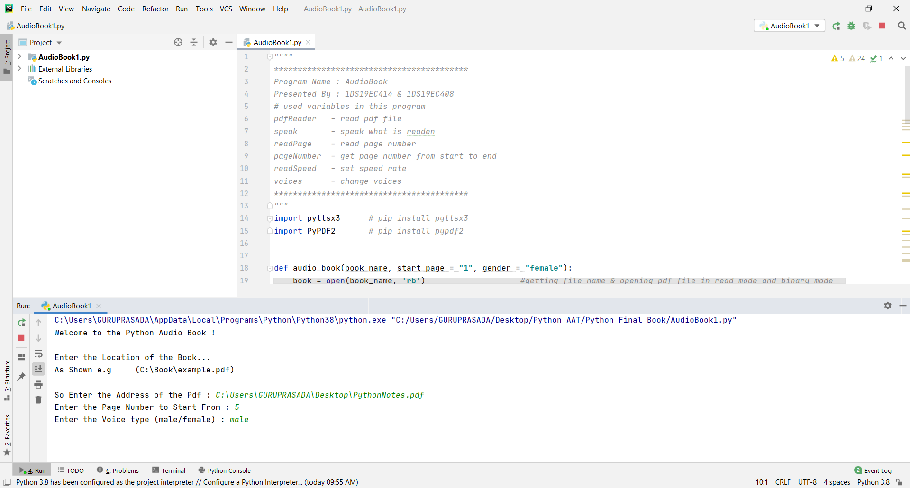

POSSIBLE TEST CASES:

- GUI based user input
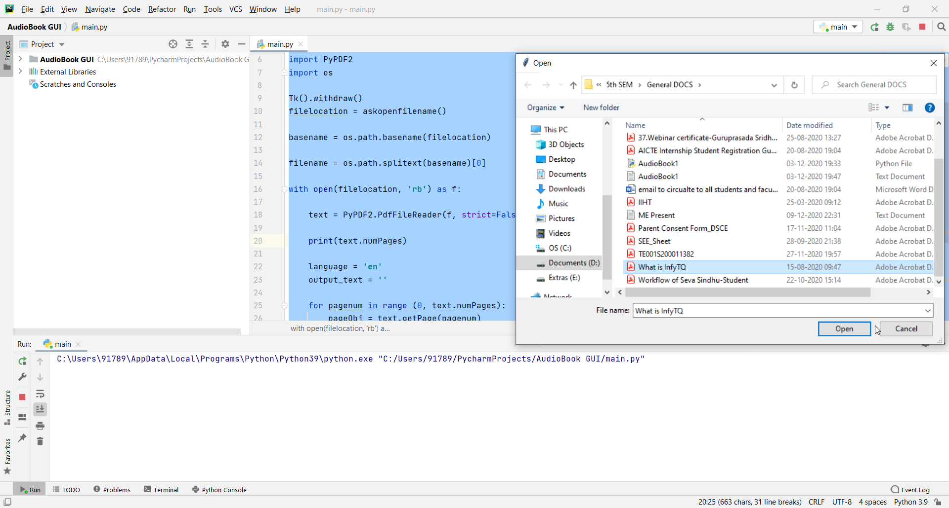
- Multiple document support
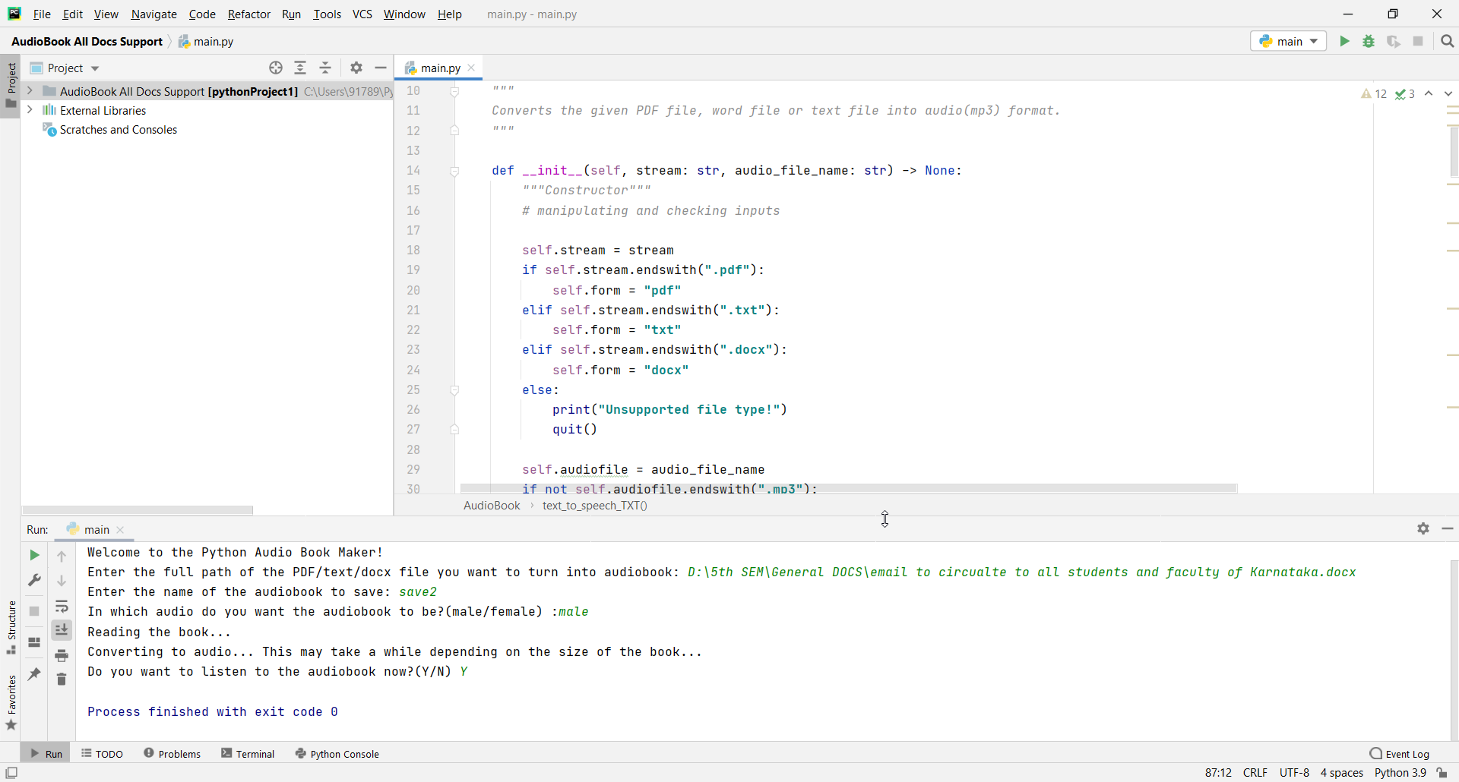

- Direct Access
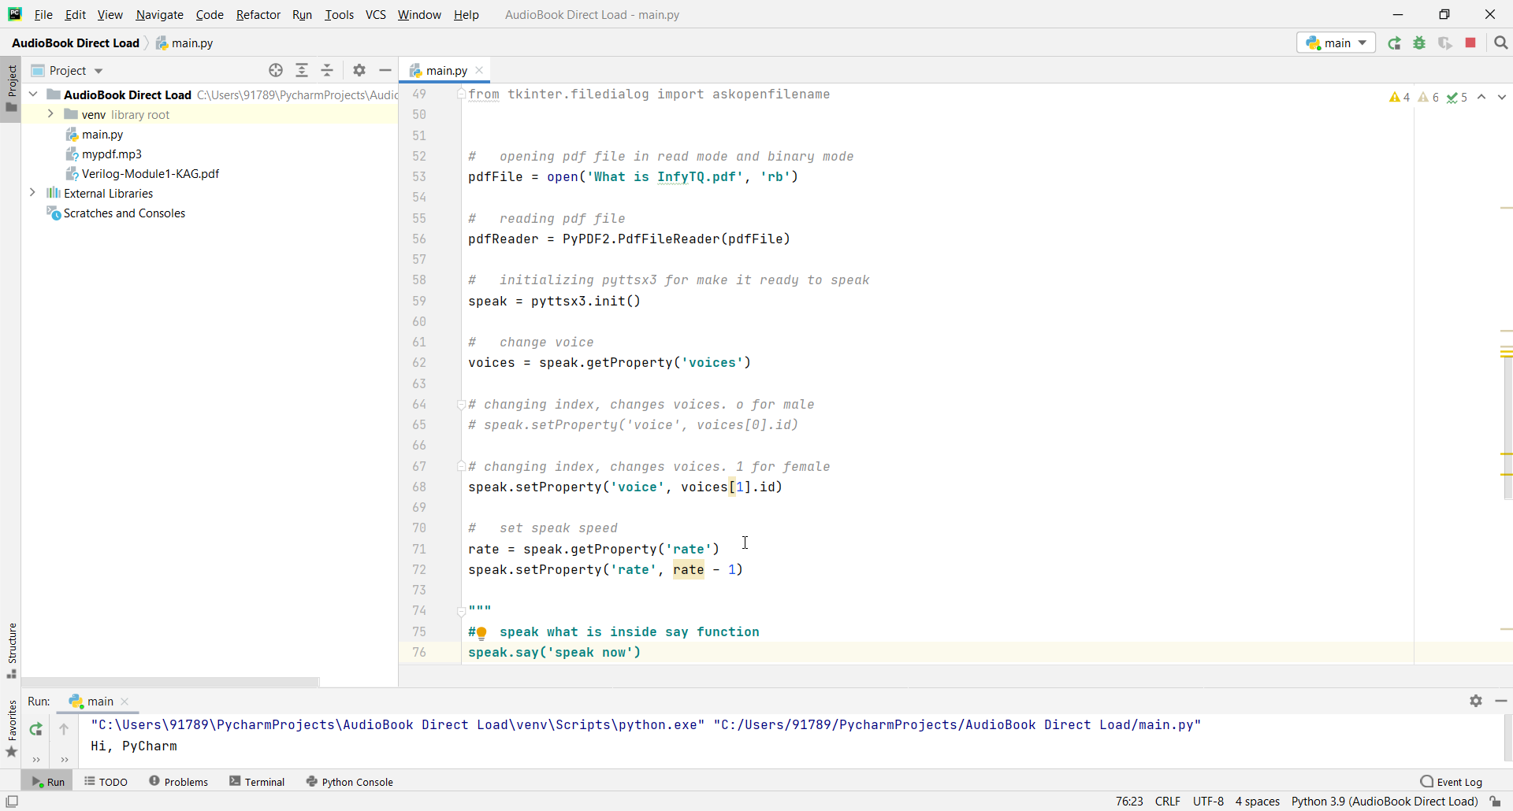

REFRENCE
[1] Deep learning With Python
[2] https://youtu.be/Flm2YHEFd5A
[3] www.audiobooks.com
[4] https://youtu.be/Flm2YHEFd5A

CONCLUSION
- we can see the usage of Audiobooks incrementing year by year globally because it can be used mainly in educational institutions and libraries.
- We are planned to build and launch an android application to create Audiobook so that user can create their own Audiobooks independently.

